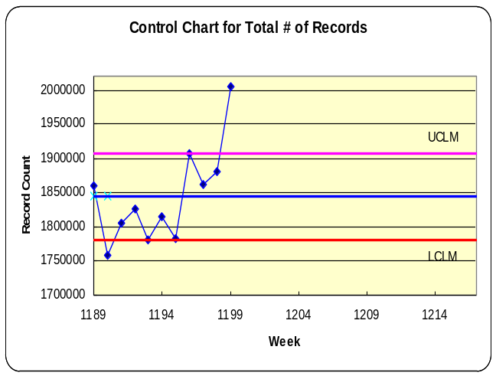In week 1199, I created the four control charts. From the charts, we saw a significant increase in week 1199 for the measure (total # of records). This indicated there was something abnormal in processing this week’s data.

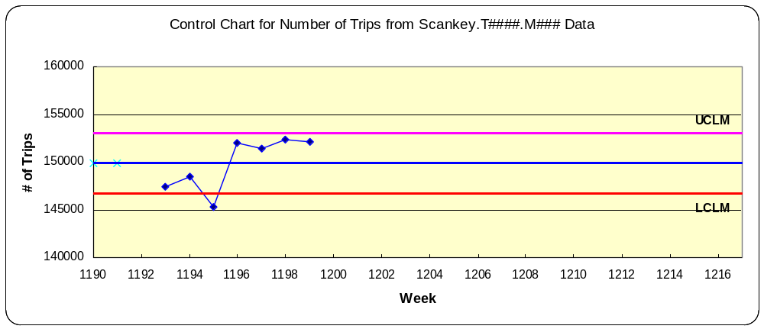In order to find out the root cause for the substantial increase, we conducted data validation in more detail. The additional charts from the raw data were normal (the data was within the control limits), which indicated that the problem was definitely process related.

